TM 10 kg (PAY 300 kg)

mc0=0; mc3=2 ; mc4=2; mcpf=1; mcbla=0.2 ;

m1=106.24;

m2=89.37;

m3=86.51;

mpf=83.65;

I1=11.43;

I2=10.83;

I3=11.43;

I4=10.83;

%I7=29.84;

sdy7=0;

sdy_ma=0;

gap=0.01;

gapPF=0.001;

gapMB=0.001;

gapIM=0.003;

gapRM=0.001;

gapTM=0.001;

%%%%% inertia %%%%%

% F1 F2 F3 F4 MB IM RM TM

m=[ m1 m2 m3 mpf 36 80 90 10.7];

Ix=[ 4 4 4 8 1.6 1.2 4 0.051];

Iy=[6.44 6.44 6.44 12 3.2 2.4 4 0.051];

Iz=[ 4 4 4 8 1.6 1.2 8 0.084];

mcre=[mc0 mc0 mc0 mc0 mc0 mc0 0 0 ];

frv=[0.33 0.33 0.33 0.33 0 0.33 0 ];

%%%%% wires %%%%%

% F1 F2 F3 PF MB IM RM TM

mat={'MA' 'MA' 'MA' 'MA' 'C70''MA' 'C70' 'W' };

l=[ 2.1 2.1 2.35 2.085 2.084 2.084 2.084 2.084 ];

d=[ 3.2 3.0 2.8 2.5 0.5 2.1 0.7 0.15 ]*1E-3;

sux=[ 0 0 0 0 0.35 0 0.34 0.25/2];

suz=[ 0 0 0 0 0.35 0 0.03 0.03];

suy=[ 0 0 0 0 0 0 0.000 0 ];

sdy=[-gap -gap -gap -gapPF -gapMB gapIM -gapRM -gapTM];

f1={1 1}; %RYU: F1

f2={1 1}; %RYU: F2

f3={1 1}; %RYU: F2

pf={1 1}; %RYU: PF

mb={4 1}; %RYU: MB

im={1 1}; %RYU: IM

rm={4 1}; %RYU: RM

tm={4 1}; %Terra=>F4=>F7=>MRM//MA=>(MI//RM)

struct= Sc(f1,Sc(f2,Sc(f3,Sc(pf,Pc(mb,Sc(im,Pc(rm,tm)))))));

TM 30 kg (PAY 300 kg)

mc0=0; mc3=2 ; mc4=2; mcpf=1; mcbla=0.2 ;

m1=106.24;

m2=89.37;

m3=86.51;

mpf=83.65;

I1=11.43;

I2=10.83;

I3=11.43;

I4=10.83;

%I7=29.84;

sdy7=0;

sdy_ma=0;

gap=0.01;

gapPF=0.001;

gapMB=0.001;

gapIM=0.003;

gapRM=0.001;

gapTM=0.001;

%%%%% inertia %%%%%

% F1 F2 F3 F4 MB IM RM TM

m=[ m1 m2 m3 mpf 36+5 80+5 90-30 20+10.7];

Ix=[ 4 4 4 8 1.6*1.4 1.2*1.06 2.2 0.275];

Iy=[6.44 6.44 6.44 12 3.2*1.4 2.4*1.06 2.2 0.275];

Iz=[ 4 4 4 8 1.6*1.4 1.2*1.06 4.4 0.14];

mcre=[mc0 mc0 mc0 mc0 mc0 mc0 0 0 ];

frv=[0.33 0.33 0.33 0.33 0 0.33 0 ];

%%%%% wires %%%%%

% F1 F2 F3 PF MB IM RM TM

mat={'MA' 'MA' 'MA' 'MA' 'C70''MA' 'C70' 'W' };

l=[ 2.1 2.1 2.35 2.085 2.084 2.084 2.084 2.084 ];

d=[ 3.2 3.0 2.8 2.5 0.5 2.1 0.7 0.15 ]*1E-3;

sux=[ 0 0 0 0 0.35 0 0.34 0.25/2];

suz=[ 0 0 0 0 0.35 0 0.03 0.03];

suy=[ 0 0 0 0 0 0 0.000 0 ];

sdy=[-gap -gap -gap -gapPF -gapMB gapIM -gapRM -gapTM];

f1={1 1}; %RYU: F1

f2={1 1}; %RYU: F2

f3={1 1}; %RYU: F2

pf={1 1}; %RYU: PF

mb={4 1}; %RYU: MB

im={1 1}; %RYU: IM

rm={4 1}; %RYU: RM

tm={4 1}; %Terra=>F4=>F7=>MRM//MA=>(MI//RM)

struct= Sc(f1,Sc(f2,Sc(f3,Sc(pf,Pc(mb,Sc(im,Pc(rm,tm)))))));

blue = 10 kg, green = 30 kg

z-tx TF (Virgo ref) (long, pitch)

(rows = resp col = exc)

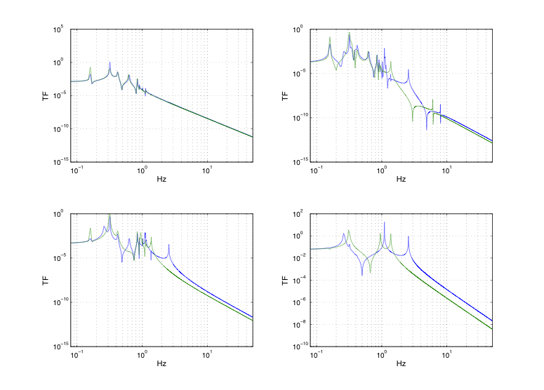

x-tz TF (Virgo ref) (transv,roll)

(rows = resp col = exc)

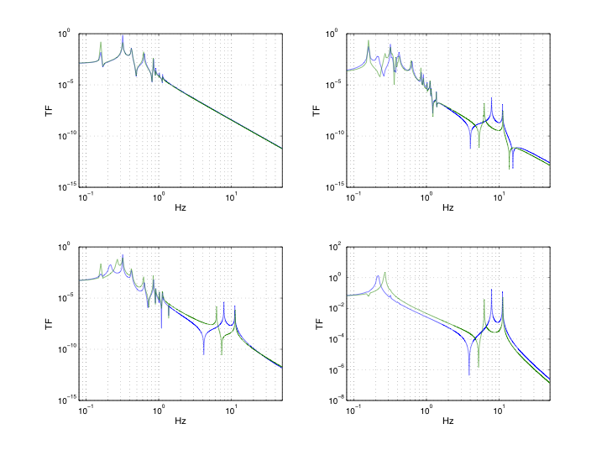

ty TF (Virgo ref) (vert)

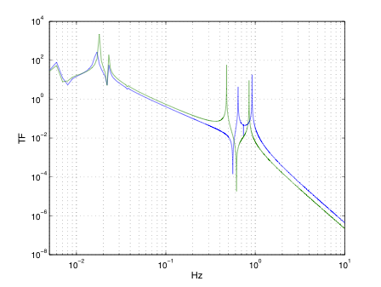

y TF (Virgo ref) 