We study three cases of test masses:

initial, with 10 kg test masses and 90 kg recoil masses

LIGO-like test masses, 40 kg test masses, 60 kg recoil masses

Heavy test masses, 90 kg test masses, 10 kg recoil masses.

The use of the same intermediate mass is foreseen for all three test mass cases.

General design features.

A clearance of 10 mm between each test mass and its recoil mass is allowed for.

The recoil mass is 100 mm longer than its test mass to allow for the implementation of 50 mm long actuator sensors.

Similarly 50 mm clearance is left all around the intermediate mass to allow for actuator sensor units. Forward facing surfaces of the recoil mass will be slanted to avoid back reflections down the pipe. Electrical wiring will route from filter four to the intermediate recoil mass to the mirror recoil mass, kept away from the intermediate and test masses.

Points understood from Ettore:

We should keep any metal or conductor at a minimum of 2 diameters away from magnets and coils. Therefore dielectric recoil masses (pyrex) are foreseen.

In normal operation the controls are applied only from the marionette (during lock the mirror is completely uncontrolled). The mirror actuators are present only to absorb the impulse when acquiring lock, and damp out the following oscillations. After that the coils on the mirror are dis-activated, if not open circuit. Because the controls are applied from the marionette, it is important that it is kept free of Eddy current noise. For this reason intermediate mass and its recoil masses are foreseen of fused silica or pyrex.

Intermediate and recoil masses will be coated with a thin layer of diamond like carbon to avoid surface charging up.

The number and kind of coil and magnets needed for controls are shown in the sketches.

There will be four sensor actuator coils for the longitudinal pitch and yaw control fo the test mass.

A damper is needed for the differential mode between test mass and recoil mass in the transversal direction. It could be as simple as mounting a small magnet on the test mass, and a coil on the recoil mass. The coil would be normally opened and shortened only for the time necessary to damp the mode.

Four vertical and four radial sensor actuator units will equip the intermediate mass in all its degrees of freedom.

The test masses will be of fused silica

The recoil mass is made of pyrex,

The flaps for the sensor actuators will be bonded with low melting point glass frit or UV curable epoxy.

10 kg test mass

m=12.5\*2.2\*r2 π/4 = 10800 g

l=10

d=25

Test mass; d=25; l=10; density 2.2 g/cm3; mass 9.984 Kg; Kg; Mx=My=51183.826 Kgmm2; Mz=84368.943 Kgmm2 normal to plane

recoil mass m= 90000

d=25+2=27

20\*2.2 \* (D2 – 272 )π/4 =mass

20\*2.2 \* (D2 – 272 )π/4 =90000

44 \* (D2 – 272 )π/4 =90000

(D2 – 272 )=2604

D2 =2604+729

D = 57.7

d = 27

L = 20

Recoil mass; D=57.7; d=27; L=20; densità 2.2; mass 89.859 Kg; Mx=My=2578758.16; Mz=4558452.509norm. al piano

Th = 15.4

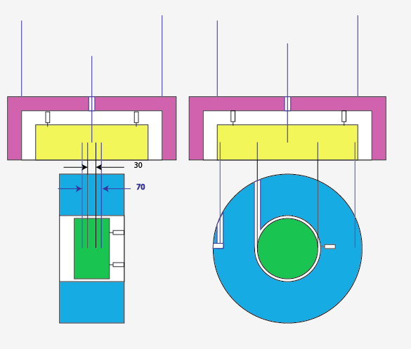

40 kg test mass

m=20\*2.2\*r2 π/4 = 40000 g

l=20

d=34

Test mass; d=34; l=20; densità 2.2; mass 39.948; x=y=421789.497; z=577255.

recoil mass m= 60000

d=34+2=36

l\*1.5\*2.2 \* (D2 - 362 )π/4 =mass

20\*1.5\*2.2 \* (D2 - 362 )π/4 =60000

66 \* (D2 - 362 )π/4 =60000

(D2 - 362 )=1157

D2 =1157+1296

D = 49.5

d = 36

L = 30

recoil mass; dens. 2.2; mass 59.832; x=y=1849650.954; z=2801821.536

Th = 6.75

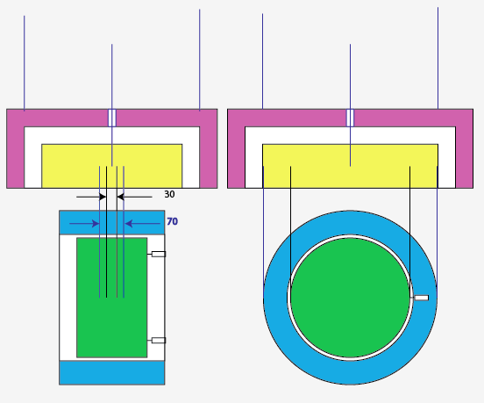

80 kg test mass

m = 25.2\*2.2\*r2 π/4 = 80000 g

l=25.2

d = 42.8

Test mass; d=42.8; l=25.2; dens. 2.2; mass 79.763; x=y=1335309.803; z=1826409.645

recoil mass m= 20000

d=42.8+2=44.8

l\*1.5\*2.2 \* (D2 – 44.82 )π/4 =mass

25.2\*1.5\*2.2 \* (D2 – 44.82 )π/4 =20000

83.16 \* (D2 – 44.82 )π/4 =20000

(D2 – 44.82 )=306

D2 =306+2007

D = 48

L = 37.8

Recoil mass; dens. 2.2; d=44.8; D=48; L=37.8; mass 19396; x=y=753536.89; z=1045187.921

Th = 2.6

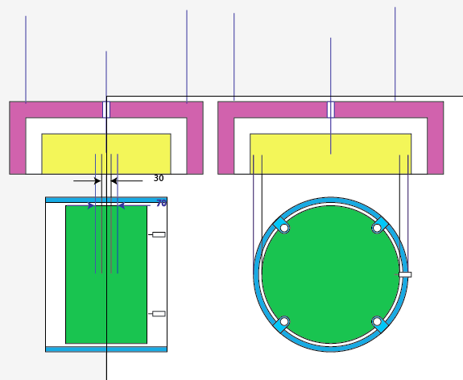

Intermediate mass

Material: fused silica plates bonded with UV curable epoxy or low melting point glass (glass frit).

The central wire attachment will use the keyhole technique used in the standard filters, while the test mass fibers are mounted with the shelf technique developed at Virgo and the keyhole technique is used for the recoil mass wires.

Mirror fused silica fiber attachment: keyhole plus indium gasket RF point-like melting.

Pitch-roll balance: picomotors on fused silica mass internally suspended and spring loaded

Nominal Density = 2.2 g/cm3

M = 40000 g

V = 18200 cm3

W = 50 cm

L = 40 cm

H = 12.5 cm

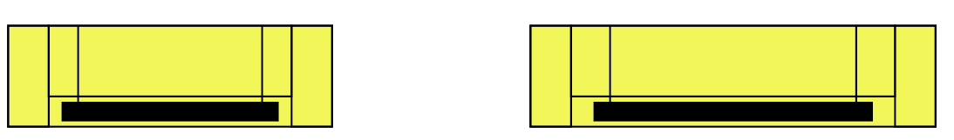

fused silica parts:

50 x125 x 400, 4p

300 x 400, 1 p

the parts are bonded with low melting point glass (glass frit)

intermediate mass; dens. 2.2; W=50;L=40;H=12.5; mass 55;

moments of inertia calculated with the approximation of a singe solid block

x=804947.917 norm. side 40x12.5;

y=1879166.667 norm side 40x50;

z=1217447.917 norm. side 50x12.5

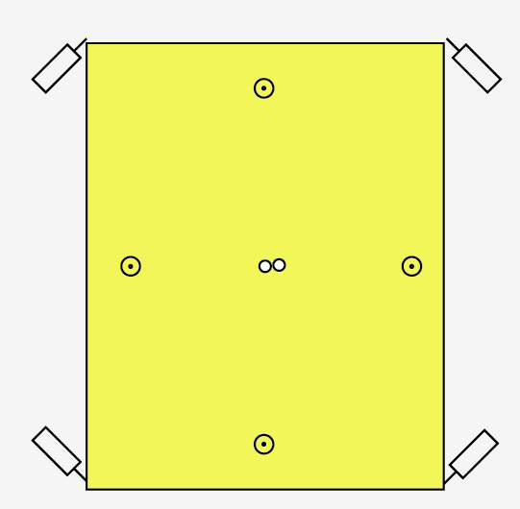

Positioning of sensor-actuators on the intermediate mass. Four vertical actuators are used for vertical, tip and roll modes. Four tangential sensor-actuator are used for yaw, longitudinal and transversal motion control

Intermediate recoil mass, it will be made out of fused silica

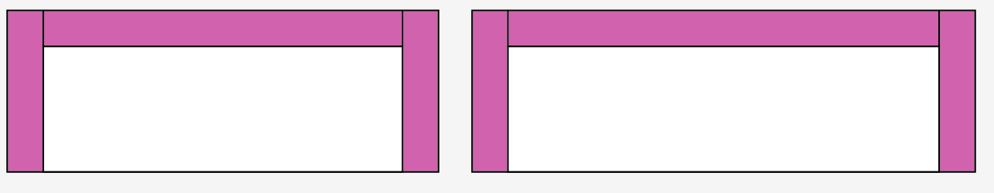

fused silica parts: 500 x 600 x50

50 x 500 x 225, 4 p

bonding, low melting point glass

Intermediate recoil mass; dens. 2.2; 500x600x225 parete 50; mass 92.4;

x=4250640.625; norm. lato 600x225;

y=5444140.625 norm. lato 700x225;

z=8855000 norm. lato 600x700

Fiber and wire attachment scheme on test and recoil masses. To avoid excess noise, fused silica to fused silica binding is obtained with an Indium membrane melted by micro RF induction.

Macintosh HD:Users:ric:Desktop:LCGT sketches:sketch attach test mass.pdf

recycler mirrors

m=12.5\*2.2\*r2 π/4 = 10800 g

l=10

d=25

Test mass; d=25; l=10; density 2.2 g/cm3; mass 9.984 Kg; Kg; Mx=My=51183.826 Kgmm2; Mz=84368.943 Kgmm2 normal to plane

recoil mass m= 10000

12.5\*8.94 \* (21.52 – d2)π/4 =mass

12.5\*8.94 \* (21.52 – d2)π/4 =10000

111.75 \* (21.52 – d2)π/4 =10000

(21.52 – d2)=115.93

d2 =506.25-115.93

d = 18.7

D=21.5

L = 12.5

Recoil mass; D=21.5; d=18.7; L=12.5; dens. 8.874; mass 9.806; x=y=62531.66; z=99526.184

intermediate mass

300 x 250 x 50 mm

material aluminum

m = 10000

1 picomotor for tilt

Intermediate mass; dens. 2.7; 300x250x50; mass 10.125;

x=54843.75 norm. 250x50;

y=128671.875 norm. 300x250;

z=78046.875 norm. 300x50

intermediate recoil mass

450 x 400 x 125 mm

material aluminum

m = 10000 g

Intermediate recoil mass; dens. 2.7;  450x400x125x10 parete; mass 10.014;

x=214972.522 norm. 400x125;

y=258895.784 norm. 450x125;

z=442884.083 norm. 450x400



Initial study of a beam splitter and recoil mass.

Beam splitter diameter = 550 mm, length =100 mm, mass = 52300 g

Recoil mass, inner diameter 570 mm, outer diameter 645 mm length = 200 mm, material aluminum, mass = 39400 g

It seems to me that a simple cylindrical recoil mass, with four sides notched as indicated, will allow using the entire available surface of the bam splitter surface, and positioning of the control magnets and OSEMs outside the profile of the maximum useful circular beam. (I neglected here the transversal beam shift inside the mirror due to its refraction index)

It occurs to me that the baffles, defining the circularity of the beams, with aperture smaller than the beam splitter maximal circular beam (at least two necessary), that also need to be seismically isolated, could be suspended from the filter supporting the marionetta. I suppose though that having other suspended masses from that filter would complicate the controls of the beam splitter, and its implementation.

I would avoid that.

The other option is to design a structure to suspend the baffles similar to what already sketched for the inner test masses of the Type-A chains.

This is useful also to fine tune independently the positioning of the baffles, without upsetting the tip-tilt equilibrium of the filter.

I also suppose that the baffles of the inner test mass would be insufficient, because the beam splitter is 25 m away from the inner test masses.

Because of the baffles and possible necessity of pickoff mirrors, I believe that we need a 2 m diameter vacuum chamber Type-B chains for the beam splitter.

